Reprinted from Proceedings of 1998 American Water Works Association (AWWA) Annual Conference, by permission.

Copyright © 1998, American Water Works Association.

Gaining Public Acceptance for Repurified Water Through Innovative Design: Blending Engineering, Architecture and Public Art

by

Douglas M. Owen, P.E., DEE
Robert Millar
Jim Shamloufard, P.E.

Introduction

Historically, public services such as drinking water treatment, wastewater treatment, and water reclamation have been ‘silent services’. As a rather unglamorous activity to the public, the services rendered have been considered a ‘right’ rather than a ‘privilege’ of society and most public works structures to support these services are relegated to the ‘out-of-sight, out-of-mind’ mentality. This is exacerbated by the facts that public works are often 1) constructed on inexpensive real estate, and 2) located in low-income areas or at the outskirts of town (at least until the community expands). In addition, the public has little, if any, inclination to view the facilities on a regular basis. Under circumstances in which the facilities are located in close proximity to residential and business sectors, the architectural response is almost universally to ‘hide’ the facility.

The collective outcome of this mindset is that the public woefully misunderstands the role that these essential services play in the survival of their community and culture. We, as engineers and scientists, have done a major disservice to our profession by attempting to make our services so transparent that the public does not know - and does not care - that we exist. Although this trend has begun to change, as a result of a great deal of negative publicity from groups justifiably concerned about the quality of the environment, our profession has been slow to react. One of the first places to look to elevate our perception is by educating the public of our efforts through a medium which can be immediately interpreted by the public - the visual image.

The City of San Diego is currently embarking on a program to recycle their wastewater. A major component is the Advanced Water Treatment Plant (AWTP). The facility will receive tertiary-treated wastewater from the North City Water Reclamation Plant (NCWRP), treat it to a high degree, and discharge the repurified water to a surface water reservoir which serves as a source water for one of the City’s three drinking water plants. The treatment process at the AWTP included membrane pretreatment (microfiltration or ultrafiltration), reverse osmosis, ion exchange, and ozone disinfection.

This paper discusses an innovative process convening an artist, architect, landscape architect, project engineer, contractor and O&M staff to determine how to present the function of a high-profile water reclamation project to the public. The process sets a precedent for how we portray the value of our services, and lends insight into how our technologies can be ‘demystified’ to the public to improve their understanding of the role of public works in our culture.

Approach and Criteria

Before the concept design began, a three day workshop was held among project team members to discuss goals and success criteria for the project. The workshop participants included engineers, architects, a landscape architect, and an art team (comprising an artist and design architect). These participants articulated a host of criteria which were believed important to deliver a successful design for the City of San Diego’s Advanced Water Treatment Plant. City staff represented by O&M, management, and public art coordination also attended. The over 40 criteria that were expressed are condensed into the following categories. The AWTP architectural, landscape architecture and public art design will be successful if the facility:

- is O&M friendly and highly functional
- meets the budget
- integrates engineering, architecture, landscaping and public art
- reflects the technology it houses
- uses natural ventilation and lighting
- ‘demystifies’ the technology and uses a visual factory concept
- is unique from, but connected to, the North City Water Reclamation Plant (NCWRP); the influent source to the AWTP
- expresses civic pride.

These success criteria continually guided the design team through the facility design.

Facility Design

Site Layout
The site for the AWTP is prominently located in a high-tech area of San Diego, near the merge of two major freeways; I-5 and I-805. The facility is long and narrow, and is located directly across Eastgate Mall from the NCWRP, as shown in Figure 1. Eastgate Mall extends westward across I-805, along a steel-reinforced concrete bridge which is elegant in its engineering, expressive of its function and is economical in materials. This design team followed this example in the design of the AWTP.

In an original project report, the facility had been conceived as a ‘campus layout’. That is, each process was housed in its own building and access to the facility was through a roadway looping among the buildings. During the workshop, the site layout was modified from the ‘campus’ arrangement to a single, integrated process facility which is 100 feet wide and 580 feet long. Figure 2 illustrates that the processes are positioned in sequence (north to south) in the order of treatment; membrane pretreatment, reverse osmosis, ion exchange, post treatment stabilization, ozonation, and repurified water pumping. Two chemical storage and unloading areas are positioned on the east side of the building in the northerly and southerly areas, to support the treatment processes located in the main building. This side of the building will also be used for primary access to the equipment for O&M staff. As such, chemical delivery and O&M activities take place along the east side of the building, shielded from view along I-805.

Roadway access will be provided in a loop surrounding the building and connecting to an underpass below Eastgate Mall. This meets all fire codes and provides vehicle access to all locations around the building by O&M staff. It also provides uninterrupted access from the NCWRP, where operations are centralized.

Building Cross-Section
The building comprises three distinct levels (see Figure 3):

- An equipment level, at grade, which will support all mechanical equipment.

- A gallery level, below equipment level, which will contain all pumping, piping and valving, and will house equipment to meet future expansion needs.

- A visitor level, approximately 16 feet above equipment level, which provides an unobstructed view of the entire facility and separates visitors from the O&M functions.

The equipment level can be directly accessed from grade on the east side of the building. This level is highly ordered with modular membrane units and is uncluttered. Feed piping and valving is in the gallery level below. Consequently, O&M staff have unhindered access to all equipment.

A 30-foot building height allows for a catwalk 16 feet above the equipment level. From this level, visitors can view the entire sequence of processes in an ordered and unobstructed fashion, thereby ‘demystifying’ the process elements.

Building Envelope
The superstructure will incorporate a pre-engineered steel frame spanning the full width of the building. This frame will support the building envelope, or ‘membrane’ which is constructed of light weight material selected to maximize natural light and ventilation. Such a superstructure is extremely economical both in its own cost and in the savings in heating, venting and air conditioning (HVAC) as well as lighting. With the proper use of materials, the only HVAC required is for relatively small operator control areas and electrical equipment. These areas are located at the northern and southern chemical storage and unloading areas, and comprise only approximately 6 percent of the building footprint. The remaining spacious areas containing the process equipment can take advantage of the significant natural ventilation at the site.

The final roof design will be evaluated based upon public input. One option considers the use of a continuous skylight along the length of the building with ventilation grills to promote cross-ventilation. Another focuses on using the roof as a surface which can be considered a ‘technological landscape’, with repetitive prism structures over the surface which allow light to enter from different angles and allow discrete process units to be highlighted differently (Figure 4).

Public Tours
This unique facility will likely attract more visitors than many other public works projects. As such, the project team focused on the visitor experience to properly communicate the function to the public. The public tour will start on the NCWRP site, enter the AWTP at the Eastgate Mall underpass, and follow along the western side of the building (See Figure 5). A ramp will gradually slope upward along the building and will be partially covered to screen the environment and focus the visitor upon intermittent views of the technology within. When the ramp reaches the north end of the building, the visitor will emerge onto an elevated platform or balcony with panoramic views of the ocean, valley and mountains. As the visitors turn to the south and enter the facility, they are met with the sound and orderly layout of the membrane technology (analogous to opening the hood of a car to reveal the engine within). The tour path continues along the eastern side of the building, with two interpretive centers located above, and adjacent to, the chemical storage and unloading facilities. The tour path then descends to the first floor, through the pumping station, into the landscape and through the Eastgate Mall underpass in returning to the NCWRP visitors’ center.

Landscaping
The landscaping concept was developed in concert with the visual design for the facility. Respect for the site, a desire to portray the function of the facility through the landscaping, a recognition of the potential for landforms using excavated materials from the underpass and building, and a desire to balance the landforms and the facility all guided the landscaping concept.

Figure 6 illustrates that the landscaping plan utilizes absence (relatively barren and arid) and excess (abundant planting) to abstractly portray the goal to membrane technology; that is, to remove all materials. This concept is further developed in the dichotomy between arid landscape (dry) and abundant planting (wet), which emphasizes the ability of the facility to produce a water resource. The arid landscape will surround the facility on the north, west and east sides, while the abundant landscape will be located only between the south end of the building and Eastgate Mall. This is the location where the final project water exits the facility.

The team recognized the potential to create an asset to the facility out of excavated material which typically is considered ‘waste’. Using a portion of this material, a prism shape is sculpted on the west side of the facility. This landform provides an opportunity to affect the transition experience of leaving the NCWRP site (with its architectural prisms) through the Eastgate Mall tunnel, and moving through the landscape into the architecture of the building. This landform also provides a balance for the building, sloping gradually downward to the north as a counterpoint to the rising visitors’ ramp on the west side of the building. This is an unusual and dramatic landscape design for an urban environment. It abstractly recognizes the relationship between what we build (architecture) and the environment (landscape).

Connection to the North City Water Reclamation Plant
The AWTP will very much be part of the NCWRP experience, and yet its architectural design will reflect its unique function. Wastewater processes, by nature, are housed in cast-in-place concrete basins which contain large volumes of liquid. Consequently, the NCWRP architecture reflects its ‘massive technology’, in the same fashion that the AWTP reflects its technology-based membrane function. Prism shapes will be provided in both the landscape and in the roofing structure for the AWTP, providing linkage to the NCWRP architectural details. The repurified pumping station, which is the closest structure to Eastgate Mall and will be the first that O&M staff and visitors encounter after exiting the underpass, is a cast-in-place concrete structure similar to the NCWRP facilities. The visual design then transforms to the north of this pumping station into an architectural design that more clearly reflects the function of the membrane technology housed at the AWTP.

Concluding Remarks

Infrastructure projects have historically been hidden and disguised from the public. This may sometimes be an economical solution, but the result of its prevalence has had the long-term effect of encouraging a less-informed public and a devaluation by the public of infrastructure projects.

The City of San Diego would not exist in its present state without the courageous and forward-thinking engineering design of water systems. Hoover Dam and the Colorado River aqueduct, which control the source for the majority of drinking water in San Diego County, were the previous generation’s solution to water supply. Mark Reisner, author of Cadillac Desert, spoke of his reaction to Hoover Dam on a recent PBS special bearing his book’s title:

“I was tremendously impressed by that dam. When I first laid eyes on it, I felt like I ought to get out of my car and kneel down and genuflect. Those engineers had built something not only immense, but really beautiful.”

It is unlikely that the dam and aqueduct system will ever be repeated as the principle means to increase water supply in the Southwest. The AWTP represents the next generation’s solution to increasing available water resources and the public should recognize, and be impressed by, the significance such facilities play in sustaining the community. The goal of the project team in developing the facility layout and visual design is to elevate the public’s perception of infrastructure and to celebrate the technological achievement that the AWTP represents.
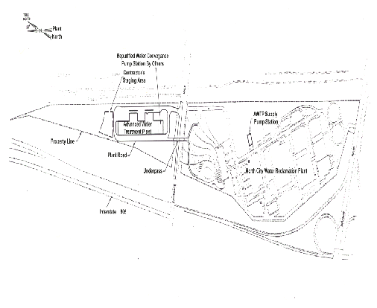
Figure 1

Figure 2
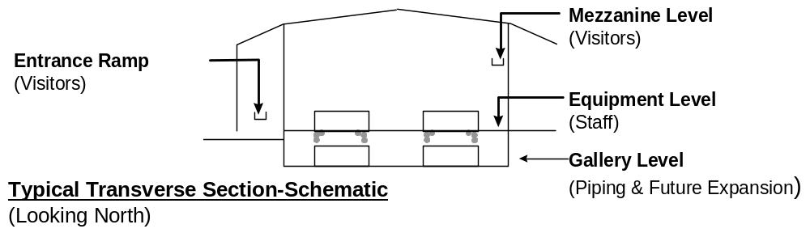
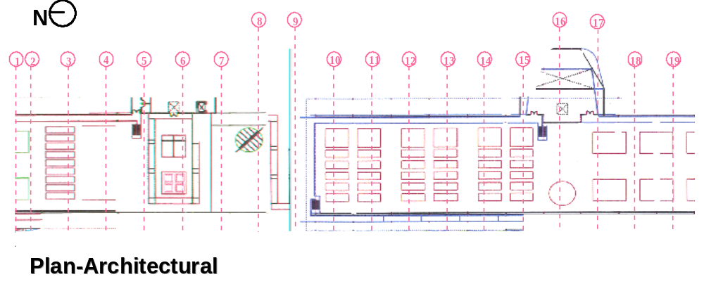

Figure 3
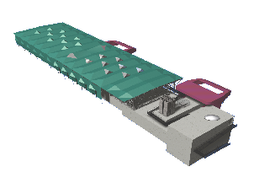

Figure 4

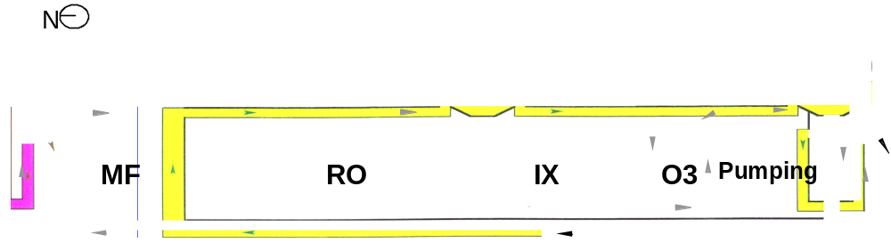
Figure 5

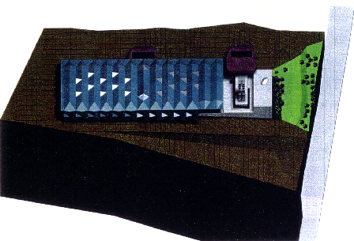
Figure 6

