Goole ‘Art on the Gate’

Public Art Commission

Artist Brief

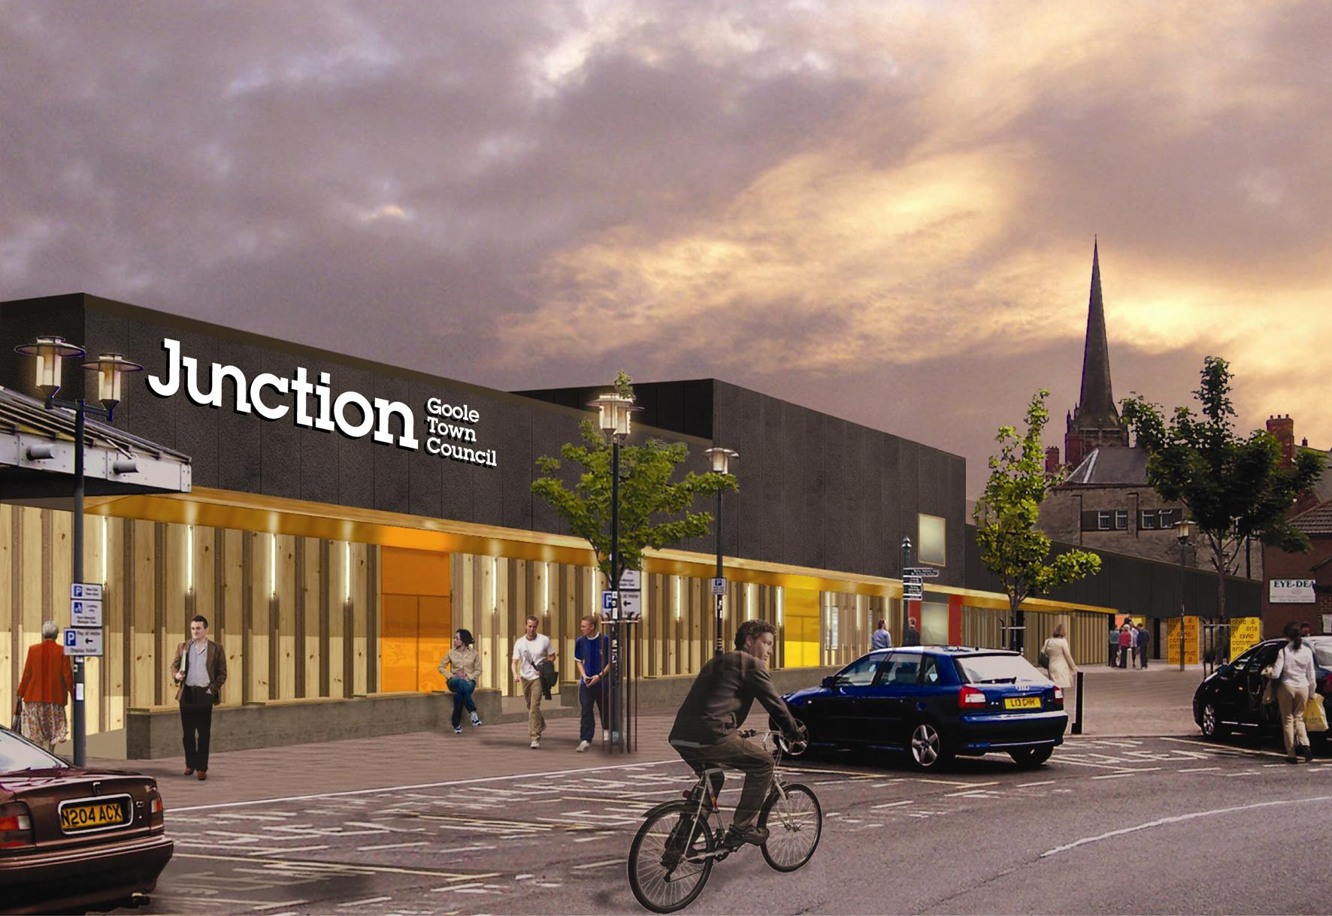

An exciting public art commission to create gates and railings for the new arts and civic centre ‘Junction’ in Goole.

Contract with: Goole Town Council
Project Location: Junction, Goole Town Council, Paradise Place, Goole
Proposed Project Timescale: Minimum of 20 sessions community consultation(session is classed as morning, afternoon or evening) with initial meeting. Start May 2009, with completed design by end of June 2009.
Fee: £5500 (to include: 20 sessions community consultation, design fee and all artist’s personal expenses) additional budget of £15000 for fabrication
Closing date for applications: 12 noon Wednesday 29 April 2009
Interviews and presentations: Tuesday 5 May 2009


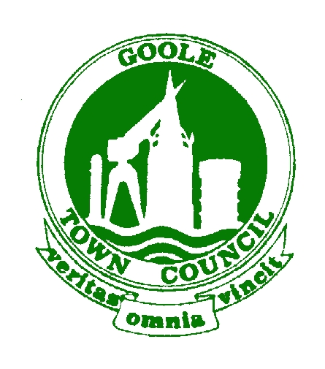
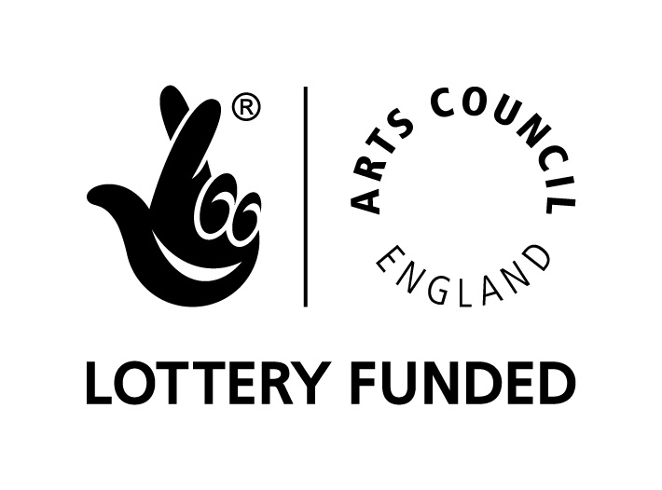

We welcome applications from individual artists, arts organisations and companies.


Artist for Goole ‘Art on the Gate’ project

The project
We are seeking an experienced visual artist to work with our town’s community to create designs for wrought iron/galvanised steel gates. The gates will be located at the front and back of the new arts and civic centre ‘Junction’ which is due to open in Autumn 2009. This building will replace the existing Gate Theatre and Goole Town Council offices in a multi-use building. The gates are very visible in a central area of Goole, and therefore a perfect opportunity for a public art commission. They do however, need to serve a security function, to close access to the covered walkway that runs up the side of the building and into the market yard at the rear. There are two parts to this project, the first part is the complete design of the gates at the front of the building, and the second part is the railings and gates at the rear of the building where there are some existing posts, gates and railings, which can be replaced (as long as it fits within the budget) or re-used and added to echoing the front gate design.

The gates at the front of the building will allow public access from the main shopping and parking area in the centre of town through the covered walkway into the market yard and the Victorian market hall. On evenings, and when the market is closed, these gates, both at the front and rear of the building will be closed. The design of the gates will need to reflect their security function and be lockable, the gates at the front of the building are proposed to be a concertina design, therefore they will need to be secured in their open position too. They also need to be durable and easy to open and close, we have thought that they would be wrought iron or galvanised steel but are open to suggestions for other durable materials that could be used within the fabrication budget.

Front Gates
At present the architect has proposed that the gates at the front of the building are in four sections. These scan be seen on the architects plans (Paradise Place and Wesley Square are the front of the building)
- Section one measures 4.37 metres and with 6 concertina panel sections,
- Section two measures 5.35 metres with 6 concertina panel sections.
- Section three measures 5.5 metres with 6 concertina panel sections
- Section four measures 3 metres with 2 concertina panel sections.
All of these will be 2.7metres high, but note these figures are approximate and the artist will be responsible for taking accurate measurements.

Rear Gates
The railings and gates at the rear of the building need to accommodate several openings. These gates and railings are not shown on the architects plans, a rough diagram is below (figure 1).
- The first section is 3.93 metres for an outwardly opening gated access to the compactor and will need to be secured by a lock.
- The second section is 3.08 metres and is for vehicular access which is currently served by two inwardly opening gates. Directly above this opening sits the Market Halls Arch (as seen in figure 2).
- The third section measures 3.93 metres and currently houses two sections of railings. This is the section where we need a fire escape gate controlled by an electro magnetic release lock.
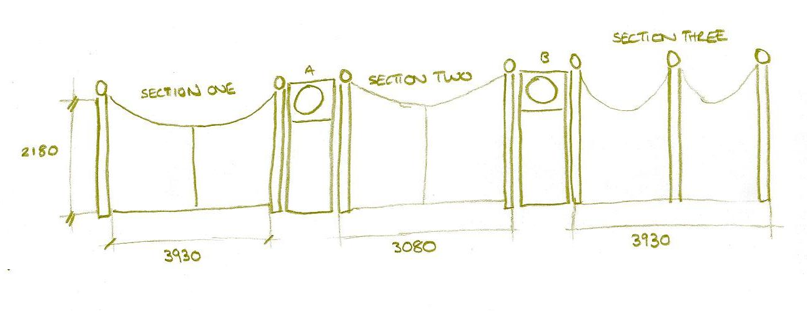
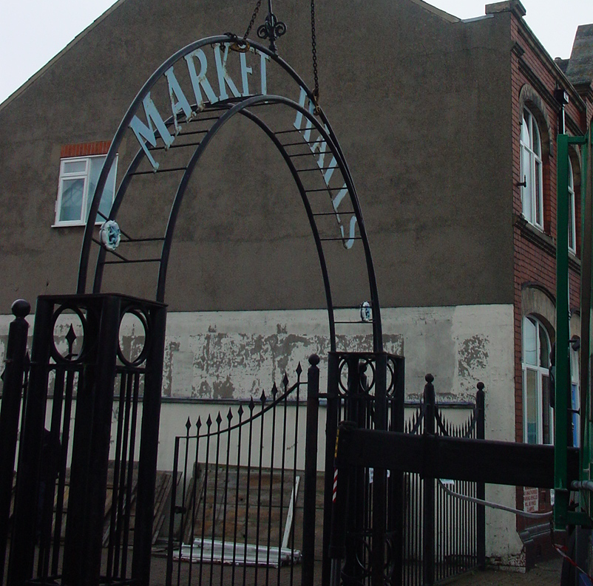
Figure 1
Figure 2

The Artist will start site visits, meetings and planning for the project in May, with the community arts consultation taking place during June, with the final design ready for fabrication in late June. The project will be managed by Goole Town Council. The artist will directly work with pre-identified client groups and community groups to explore ideas around the designs of the art works. It is expected that the artist will liase with Goole Town Council, the architects (Bushow Henley), the contractor, (Houltons) and the fabricator to further develop these designs. Potential artists may propose to work with a preferred fabricator or Goole Town Council can supply contact details for local firms.

The artist
The artist will be a professional person with experience of a project of a similar nature before, and a good track record of creative community involvement in their work. The appointed artist will be able to demonstrate the following:

Experience

Essential
S/he should have successfully delivered projects of a similar nature in the past.
Experience of working on designs to be fabricated.
Experience of working with architects, contractors and fabricators
Excellent communication skills
Experience of working in direct response to desires/needs/wants of participants
Excellent time management
Excellent organisational skills
Resourcefulness
Has been positively vetted by the Criminal Records Bureau & willing to undertake further Enhanced Disclosure.
Awareness of child protection and health and safety issues

Desirable
Experience of using arts in a community setting
Has worked on a project of a similar nature before
Has current first aid certificate

Skills required from Artist
Ability to deliver the project on time
Ability to co-ordinate, lead and deliver effective workshops, discussions and meetings
Ability to communicate effectively at an appropriate level with children, young people and adults
Ability to encourage creative ideas
Ability to deliver consultation events/workshops in a friendly, accessible, yet professional manner
Ability to use own initiative

How to apply - Interested parties should submit the following:

- Confirmation on their availability to complete the design by the end of June.
- Identity of the person or persons wishing to undertake the project with a CV demonstrating that they have the experience and skills required
- A description of your approach to the project and a simple implementation timetable
- A written example of a similar project recently undertaken
- One example of your work (e.g photos, video, CD rom,) these will all be returned to the applicants
- Contact details for two referees (one of which should be for a project of a similar nature)
- Evidence of CRB enhanced disclosure (or agreement to undertake one)
- Evidence of equal opportunities policy (if application is from a company or partnership)
- The company/individual will provide their own public liability insurance to the value of £2,000,000. A copy of the policy should be submitted. If you do not currently have a policy please indicate your willingness to take one out should your application be successful.

Please send applications marked ‘Art on the Gate’ to:
Nicola Dixon, Youth and Community Arts Co-ordinator, Goole Town Council, 17 – 23 Gladstone Terrace, Goole DN14 5AQ. Applications may be submitted by email to nicola.gtc@btconnect.com
Applications to be received no later than 12 noon Wednesday 29 April.

Once applications have been submitted, candidates will be shortlisted. The interview will include a site visit and short discussion/presentation.

Should you have any queries about the project, please contact Nicola Dixon, Youth and Community Arts Co-ordinator, Goole Town Council on 01405 763652 or email nicola.gtc@btconnect.com

